CHE517 ADVANCED PROCESS CONTROL
FINAL EXAM
Professor Shi-Shang Jang Jan. 15, 2009

Problem #1 (25%)

Consider the following process, show that:
(1) 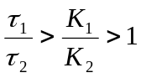, then the zero the on the right half plane.

(2) 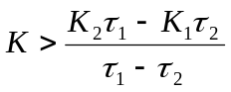, then the closed loop zero is on the lift half plane
(3) Perform dynamic simulation and discuss the results using SIMULINK for the closed loop system if the model based prediction unit 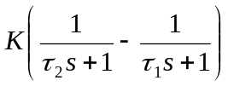is and is not implemented. (Use the following parameters (τ₁=5, τ₂=1, K₁=3, K₂=1, K should be implemented appropriately based on (2).)

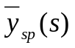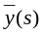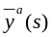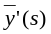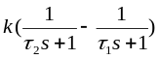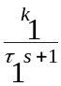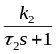
G_{c}(s)
Process with inverse response
Controller mechanism
+
-
+
-
Controller
+
-

Problem #2 (25%)
(i) Consider the following multivariable plant
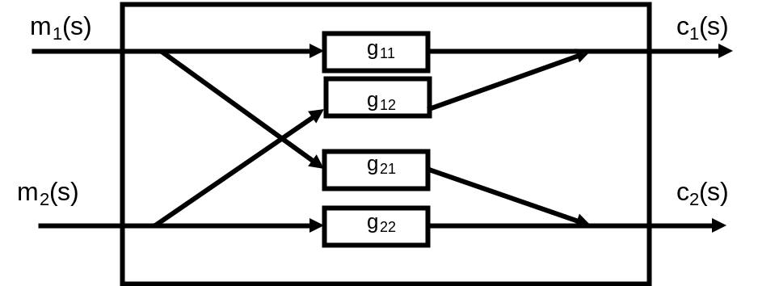
with a decoupler:
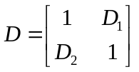

find the analytical solution for D.
(ii) Consider
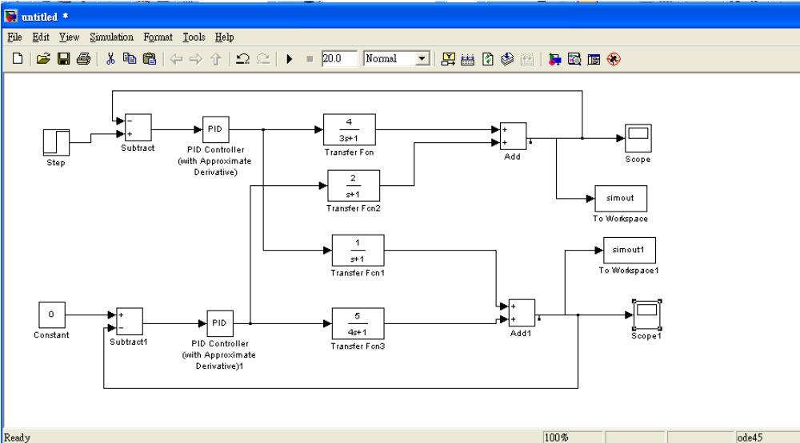
Implement the decoupler derived above and perform a SIMULINK simulation to demonstrate the superiority of the decoupling scheme.

Problem #3 (25%)
Consider the following two plants:
(1) 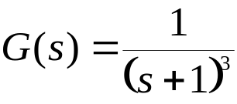
(2) 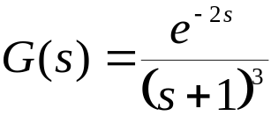
(i) Design PID controllers for both plants based on Ziegler-Nichols quarter decay ultimate properties rules.
(ii) Improve the PID controller performance for the second plant using Smith Predictor Approach without any modeling error.
(iii) Consider the modeling by assuming the model implemented is:
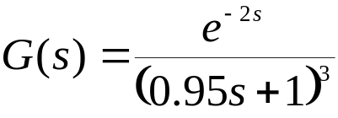
How bad is the performance using Smith predictor?
Solve the above problem using MATLAB and SIMULINK.

Problem #4 (25%)

(i) Construct a pulse response model for the following process:
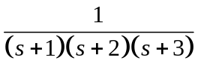
with H=10.
(ii) Demonstrate the predicting capability using a random number input to the process and model simultaneously.
(iii) Design a MPC controller and show that the controller works with P=4, B=4.
(iv) Show that MPC controller and show that the controller works with P=4, B=2.

